**Leader Overview**

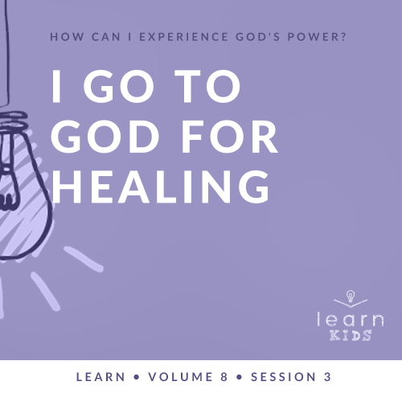

**Volume Overview**

**How can I experience God’s power?**

*When we think of power, we might think of physical strength or mental toughness. While God surely wants us to experience physical health and clarity of mind, He desires that we experience His supernatural power too.*

*In the Bible, it’s clear that our God—revealed through the Father, the Son and the Holy Spirit—is powerful. He spoke the world into existence and sustains the universe by the power of His Word (*[*Hebrews 1:3*](https://ref.ly/logosref/Bible.Heb1.3)*). God displayed His power in many ways in the Old Testament for His people. In the New Testament, Jesus’ life and works revealed His power over sickness, spiritual forces, and even the grave. After Jesus’ resurrection, God sent the Holy Spirit so we could have the power to do kingdom work today (*[*Acts 1:8*](https://ref.ly/logosref/Bible.Ac1.8)*). Clearly, God is powerful! But how do you and I experience His power? That’s the question we’ll explore in this volume.*

**Session Overview**

**I Go to God for Healing**

*In today’s session, kids will learn that God has power to heal people. In the Bible story, Naaman was a very important man with a very big problem. He thought he had to live with his skin issue until a young servant girl spoke up about healing being possible. Naaman’s journey led him to God and the recognition that he needed to do things God’s way. Kids will see that God not only can heal them, but He can also use them to put His healing power into action in the life of others too.*

**Bible Lesson**

Naaman’s Healing

[2 Kings 5:1–14](https://ref.ly/logosref/Bible.2Ki5.1-14)

**Faith Fact**

I believe God can heal.

**Faith Verse**

[John 14:12](https://ref.ly/logosref/Bible.Jn14.12) (NLT)

“I tell you the truth, anyone who believes in me will do the same works I have done.”

**Preparing for the Session**

**Leader Preparation Time: 20–25 Minutes**

|  |
| --- |
| ***You Will Need***  ***Large Group***   * *Bible* * *Worship songs (Song suggestions: “Way Maker” by Hillsong Worship; “Miracles” by Vertical Worship; “Nothing Is Impossible” by Planetshakers; “Love Won’t Let Me Down” by Hillsong Young & Free)* * *For groups not using a phone or tablet only, add:*   *• Projector or TV*  *• Laptop*  *•* ***Faith Fact Slide***  *•* ***Faith Verse Video*** *or* ***Slide***  *•* ***Bible Lesson Video***  *•* ***Teaching Point Slides 1–3***   * *Poster board* * *Permanent marker* * *Charger for a phone or laptop*   ***Small Group***   * *Bibles for kids in your group to share* * *Balloons, one per kid* * *Candy or small prizes, one per kid* * ***Small Group Activity Page****, one per kid* * *Pencils, one per kid* * *Crayons or markers*   *To access session content and videos from a computer, visit:* [*BibleEngagementProject.com/downloads*](https://bibleengagementproject.com/downloads) |
| ***Getting Ready***  ***Large Group***   * *Download videos and slides if needed.* * *Select worship song(s) and have them ready to play.* * *Read the Bible Lesson Scripture to prepare for Teaching Time.*   ***Small Group***   * *Print copies of the* ***Small Group Activity Page****, one per kid.*   *First time leading* Learn *for Kids? Check out the* [*Facilitator Guide*](https://0b769b0ed3569ef9d18b-f88d8272f61086866d50d048b43ef630.ssl.cf2.rackcdn.com/sites/biblengagementproject/Listen_Facilitator_Guide.pdf)*.* |

**Large Group**

**30 Minutes**

*See what’s needed at the beginning of the session.*

**Introduction**

Welcome! I have one special word I want everyone to repeat as loud as you can. Are you ready for the word? *(Group response)* The word is *go*. Everybody say, “Go.” *(Group response)* That was pretty good, but I feel like you could say it even louder than that. One more time, say, “Go.” *(Group response)* Great job!

Who do you go to when you need help? *(Allow responses.)* Those are all terrific people to go to. Today, we’ll talk about going to God when we or someone we know needs healing. God is the first One we should go to for just about anything, but especially when someone is sick and needs God’s help to get better.

**Faith Fact**

That’s why our Faith Fact for today says: **I believe God can heal**.

• *Show the* ***Faith Fact Slide.***

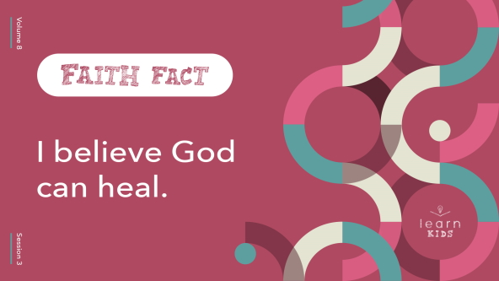

We’re going to say that all together. First, touch your head and say the Faith Fact. *(Group response)* **I believe God can heal.** Now touch your toes and say the Faith Fact. *(Group response)* **I believe God can heal.** Finally, touch a part of your body where you or someone you know is hurting or sick right now. *(Group response)* Let’s say our Faith Fact one more time. **I believe God can heal.** What a wonderful reminder that God can heal us from our head to our toes. There is nothing God can’t do!

**Game**

**Leader Says**

When a leader tells you to do something, what should you do? *(Group response)* You should do it! It’s even more important to follow God’s directions. We’ll see that in our Bible story today about Elisha and a man named Naaman.

First, let’s play a game. You’ll win if you listen to the leader and follow the instructions. The leader will tell you to do lots of different things, but only do something if the leader says, “Leader says” first. If you don’t hear, “Leader says,” don’t do it. Let’s give it a try. Leader says, “Stand up.” *(Group response)* Leader says, “Touch your nose.” *(Group response)* Good job! Are you ready to listen and follow instructions? *(Group response)*

• *Give kids easy-to-follow directions like these:*

• *Jump.*

• *Clap your hands three times.*

• *Pat your head.*

• *High-five your neighbor.*

• *Say the Faith Fact.*

• *Alternate between saying, “Leader says” and not saying it.*

• *Kids should not be removed from the game if they make a mistake. The object is to help kids listen to and follow directions.*

• *If time allows, let kids take turns being the leader.*

Some of you were better than others at following instructions. That’s true about the people in our Bible story today too. It’s important to listen to God and follow His instructions for our life.

**Worship**

I’m so thankful we can go to God for anything! One of the ways we can go to God is through our worship. Let’s worship Him today with all we have as we sing.

• *Lead the kids in singing one or two praise songs. See suggestions at the beginning of the session.*

**Bible Lesson**

Thanks for worshipping God with me today! Now it’s time to go to God through His Word. Let’s hear what the Bible says about God’s healing power. Our incredible true story today is about an important man named Naaman. He didn’t really know God, but he needed to be healed of an awful skin disease called leprosy. Someone said he should go to God’s prophet to be healed. Do you think he followed directions? We’re going to find out what happened, but first we need to pray and invite God into our Bible time today.

**Prayer**

|  |
| --- |
| *Dear God, thank You for always being there for us. Help us remember to go to You first when we need help. Amen.* |

**Video Intro**

Just before we get into the Bible story, let’s check out this video.

• *Play* ***Bible Lesson Video****.*

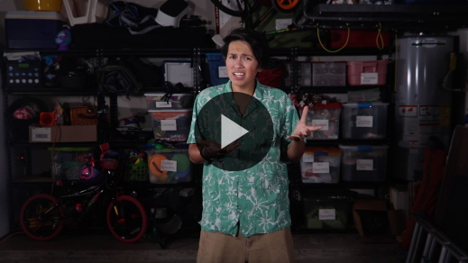

**Bible Story**

**Naaman’s Healing**

That video really made me want to find out more about our Bible story today! Naaman was a super important leader, but he was sick. He didn’t know how to get healed of his skin disease until someone mentioned the prophet of God—Elisha. God’s healing power came to Naaman in a way he wasn’t expecting. God sent him instructions through someone Naaman didn’t think was very important.

Now that I have your attention, grab your Bible or open the Bible app on your device and go to [2 Kings 5:1–14](https://ref.ly/logosref/Bible.2Ki5.1-14) to read along. Let’s find out how Naaman was healed.

• *Read the Bible story aloud to the group.*

• *In order to keep Large Group time moving along, we don’t recommend having the kids read.*

• *Optional: Remind the kids to mark this place with their Bible Bookmark, so they can read it on their own at home.*

**Teaching Time**

|  |
| --- |
| ***You Will Need***   * *Poster board* * *Permanent marker* * *Charger for a phone or laptop*   *No prep is needed.* |

Naaman probably didn’t know about our God and had never felt His power before. But he really wanted to be healed, so he traveled to Israel for help. God knew that Naaman needed His help to be healed and to find out who God was. God chose to heal the leprosy to show Naaman His power. I’m sure that after that day Naaman always went to God when he needed help.

But Naaman was slow to obey at first. So let’s say the Faith Fact in slow motion. **I believe God can heal.**

• *Lead the kids in saying the Faith Fact together as slowly as possible.*

Let’s talk more about why we need healing and how God’s healing power works.

**1. God wants people to have good health.**

• *Show the* ***Teaching Point 1 Slide.***

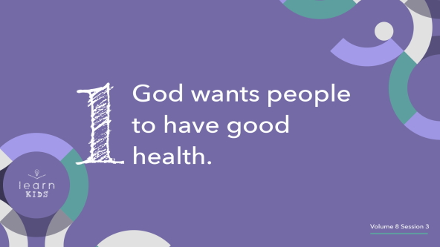

God is our Creator. He knows us better than we know ourself. His love for us is too big to measure. When God created Adam and Eve, the first man and woman, He wanted them to live perfect lives with perfect health forever. It’s hard to imagine a perfect world because we’ve never seen it. But let’s try really hard to use our imaginations today. Everyone close your eyes and imagine a perfect world.

• *Pause while kids close their eyes.*

Keep your eyes closed. What do you imagine in your perfect world? *(Allow responses.)* Can you imagine a world where there would be no sickness, no death, no accidents, no sadness, no pain, no bad days? *(Group response)* Okay, you can open your eyes now. Our perfect world sounds pretty amazing, doesn’t it? For Christians, we’ll get to live in that kind of perfect world one day when we go to heaven—but not here on earth now. Here’s why.

It’s sad, but Adam and Eve didn’t follow God’s plan or listen to His instructions. Because they didn’t obey God, sin came into the world. Sin is why our world isn’t perfect. Every person who ever lived—except Jesus—has sinned and made mistakes. Sin always causes bad things to happen. One of those bad things is sickness.

God wants people to have good health, but because of sin, we get sick. Now that doesn’t mean if you get sick, it’s because you did something bad. It simply means sickness exists in the world because of everyone’s sins.

**2. God still heals people today.**

• *Show the* ***Teaching Point 2 Slide.***

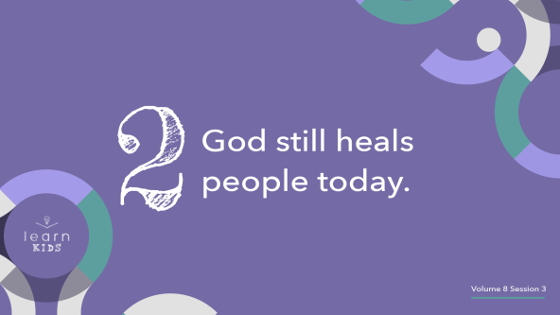

All through the Bible, we can find many stories of God’s healing power.

• *Hold up the poster board and marker.*

Let’s see if we can fill this big poster board with miracles of healing. If you know of a healing in the Bible, raise your hand.

• *Call on kids and write the healings on the posterboard as you go.*

• *Optional: Have an adult volunteer write them to keep things moving along.*

Wow! That’s a lot of healing power! But sometimes it’s easy to look at all God did thousands of years ago and wonder if He still heals people today. Maybe you think we don’t see as many big miracles now as the people in the Bible did. When you read the Bible, it can seem like the miracles happened very close together. But did you know the Bible actually covers thousands of years? (*Group response*) God didn’t heal every sick person in Bible times, and He doesn’t heal every sick person now. But He does still heal. Let’s be ready for His healing power in our life.

**3. God can use anyone to help in His healing.**

• *Show the* ***Teaching Point 3 Slide.***

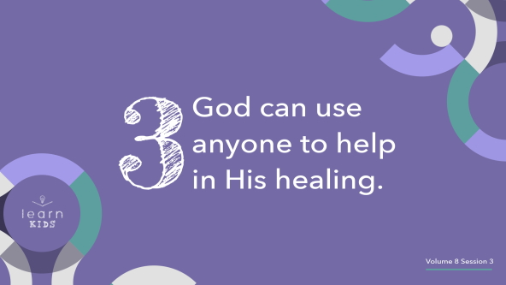

God loves to work through His people—even when He heals! God is the Healer, but He uses people to help in His healing. This happened a lot in the Bible. God doesn’t usually just heal someone out of nowhere. He loves to include His people when He heals someone, just like He included Elisha when Naaman was healed.

Can God heal without anyone’s help? *(Group response)* Of course He can! But God knows how powerful it is for someone to pray for a sick person and be part of God’s healing miracle. We’re kind of like a phone or computer charger.

• *Hold up a charger.*

A charger has to be plugged into an electrical outlet to send the power to charge the device. We’re the same way. We don’t have power to heal people on our own, but God can use us to transfer His healing power to others. He can use anyone, not just pastors and adults. In our Bible story, the first person who said God could heal Naaman was a young girl. Elisha believed God wanted to heal Naaman too, but Naaman had to trust God for his own healing.

**Prayer and Response**

*Consider playing a worship song softly in the background while kids pray.*

Let’s go to God for healing right now. If you’ve never asked God to heal you before, raise your hand. *(Group response)* I appreciate your honesty. Let’s change that right now. If you need to be healed today, stand up. *(Pause while kids respond.)* If you know someone who needs to be healed today, stand up. *(Pause while kids respond.)*

We’re going to follow the Bible’s instructions as we pray for healing today. In [Mark 16:18](https://ref.ly/logosref/Bible.Mk16.18), Jesus told us that His followers can place our hands on sick people and they will be healed. Gently laying your hand on the shoulder or arm of a sick friend as you pray is one way to show you care about them and believe God can heal them. So if you’re seated, I want you to get up and stand near a person who needs healing.

When we pray to God for healing, remember He may heal some people today, and He may choose not to heal others. Our Faith Fact reminds us that our job is to believe God can heal us and also to trust Him if healing is not in His plan for us. So let’s pray and ask God for His healing power.

• *Encourage kids and leaders to gather around those who are asking for healing and gently lay hands on them.*

• *Invite kids to share what they are praying for with the people around them.*

• *Then ask people to pray over them.*

**Prayer**

• *Optional: Have the kids repeat phrases of the prayer after you.*

|  |
| --- |
| Dear God, we ask You to do what only You can do. We pray that You would heal everyone here who has a need. We believe You can heal. Help us to continue bringing You all our needs. Amen. |

**Faith Verse**

I love that the Faith Verse tells us anyone who believes in Jesus can do what He did. One of the key words to remember in that verse is *anyone*. It doesn’t say “anyone who was there in the room with Jesus that day.” It just says *anyone*. That means you and me! Let’s say the Faith Verse together as we do the actions.

• *Play* ***Faith Verse Video****.*

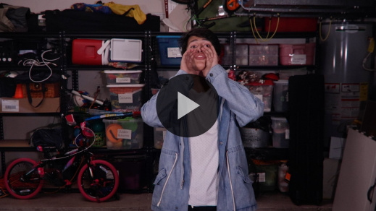

[John 14:12](https://ref.ly/logosref/Bible.Jn14.12) (NLT)

“I tell you the truth, anyone who believes in me will do the same works I have done.”

Remember you can be the “anyone” Jesus was talking about in that verse. It starts with believing in Him and asking Him to fill you with His power.

**Faith Fact**

Before we go to our small groups, let’s go over our Faith Fact one more time.

• *Show the* ***Faith Fact Slide****.*



Say it with me. **I believe God can heal.** When you leave today, I hope you remember to go to God every single day this week and pray for people who need healing. Don’t wait for Sunday or church to talk to God. You can experience His power every day.

• *Dismiss kids to Small Group time or to go home if your group time ends here.*

**Small Group**

**30 Minutes**

*This section can be done in conjunction with the large group or on its own if you do small groups with your kids. During Small Group time, the goal is to connect the kids with the Word of God and to each other. All activities are led by the small group leader.*

**Group Connection**

**Do What I Do**

In our Bible story, Naaman almost missed his healing. Why was that? *(Allow responses.)* Naaman didn’t want to do what the prophet of God, Elisha, told him to do. We can learn a lot about following God from this Bible story. We don’t want to miss God’s miracles because we won’t obey.

In this game, we’re going to practice obeying when someone else wants us to do something. You’ll pair up and choose who will be the leader for the first round. Then just like Elisha gave Naaman steps to follow, the leader will say and do one action. They might wave their arm, stomp their foot, blink their eyes, shrug their shoulders, or do another simple move. Then the partner who is following will do the same action. Let’s practice!

• *Allow kids to pair up, choose who will lead, and do the first action.*

That looked great. But here’s the challenge. There will be six more rounds. Each round, the leader will say and do a new action. The follower needs to remember and do the actions from all the rounds in order! If one of the partners forgets an action, the team is out until it’s time to switch places. I’ll count off the rounds. Let’s go!

• *Call out the rounds, giving more time to repeat actions as you go.*

• *Celebrate the winners. Have the partners trade roles and play again.*

It got harder and harder to remember all the actions in order, didn’t it? (*Group response*) What a relief that God usually gives us directions only as we need them. If He told us everything we needed to know, we would forget it when we needed it most.

**Learn about It**

|  |
| --- |
| ***You Will Need***   * *Bibles for kids in your group to share*   *No prep is needed.* |

**Scripture Search:** [**1 Peter 2:24**](https://ref.ly/logosref/Bible.1Pe2.24)**;** [**2 Corinthians 1:4**](https://ref.ly/logosref/Bible.2Co1.4)**;** [**Matthew 14:13–14**](https://ref.ly/logosref/Bible.Mt14.13-14)**;** [**Mark 16:17–18**](https://ref.ly/logosref/Bible.Mk16.17-18)

Let’s dig deeper into God’s Word and see what else He says about coming to Him and believing that He is our Healer. As we find and read each of these verses, let’s think about this question: What does this Scripture mean for our life today?

• *Give each kid a Bible and search for one or more of the Scriptures as a group together (as time allows). When everyone has found the Scripture, have one of the kids read it. Then answer the question about it: What does this Scripture mean for our life today?*

• *Pair kids who need additional help with older kids or start simple and look up the session’s Bible story Scripture:* [*2 Kings 5:1–14*](https://ref.ly/logosref/Bible.2Ki5.1-14)*. Kids will get better at finding Scriptures the more they practice.*

• *Optional: Make this a competition to see who can find the Scripture first.*

**Bible Reading Tip**

When we think about God’s healing power, we mostly think about Him healing our body. But God can heal our emotions and mind too. One of the ways God heals us when we’re struggling is through His Word. There are verses in the Bible we can read or memorize that can help us believe for healing no matter what we’re struggling with.

Think about what kind of healing you need and search for Bible verses dealing with it. (If you’re searching online, be sure you first ask your parent or guardian for permission or help.) Maybe you need healing from anxiety or fear. You could search for “Bible verses that help with anxiety or fear,” and a lot of Bible verses will pop up for you to find and read. If you struggle with that issue often, mark those verses in your Bible so you can find them easily when you need them. Allow God’s Word to heal you and get rid of what needs to go.

**Challenge**

Your challenge is to keep asking and believing God for healing. Healing usually happens when someone asks for it and believes it can happen. God can use your prayers right now to heal someone. Maybe you’ve never done that before. Or maybe you’ve asked God for healing in the past, but God didn’t heal you or the person you were praying for. Even if God answers with “not right now” or “no,” that doesn’t mean you should stop asking for healing.

**Faith Fact**

Remember our Faith Fact for today: **I believe God can heal**. Let’s take turns saying the words. I’ll say the first word, you’ll say the second word, and so on. Here we go!

• *Lead the kids in saying the Faith Fact again, alternating between the leader saying a word and the kids saying a word.*

**Group Discussion**

*Feel free to use all or just a few questions as a jumping-off place for good discussion. Questions marked with * are designed for more conversation. Adjust the questions based on the age or maturity of your group. Typically, older kids will be able to dive a little deeper than younger ones.*

**Questions**

• *If small group activities are not immediately following large group time, you may want to read the Bible story passage before this discussion.*

Who was the first person who helped Naaman on the path to healing?

What did Naaman have to do to be healed?

* Why can it be hard to follow instructions?

Are you good at following instructions? Why or why not?

Do you listen to your parents or other adults and obey what they tell you to do?

Is it hard or easy for you to believe in healing? Why?

* Have you ever asked God for healing? What happened?

*Have you ever seen a healing? Share about it.

What is something you could ask God to heal in your life?

* Why do you think God doesn’t always heal us when we ask?

**Prayer Requests**

*Finish group discussion by sharing prayer requests and praise reports. Keep track of your small group’s prayer requests and review them each time you meet.*

**Prayer**

*Have kids pray for each other’s prayer requests.*

**Faith Verse Review**

Our Faith Verse is [John 14:12](https://ref.ly/logosref/Bible.Jn14.12). This verse is powerful when we put it into practice! Say it with me, and then we’ll play a fun game together.

• *Show* ***Faith Verse Video****.*



[John 14:12](https://ref.ly/logosref/Bible.Jn14.12) (NLT)

“I tell you the truth, anyone who believes in me will do the same works I have done.”

**Faith Verse Fun**

**Pop It and Say It!**

|  |
| --- |
| ***You Will Need***   * *Balloons, one per kid* * *Candy or small prizes, one per kid*   *No prep is needed.* |

Who thinks they know the Faith Verse without any help? *(Group response)* That’s good because everyone is on their own for today’s game. You need two skills: blowing up a balloon and saying the Faith Verse. Here’s how we’ll play.

I’ll give each of you a balloon. When I say, “Go,” start blowing up your balloon. When I say, “Stop,” stop blowing and hold your balloon tightly shut. Don’t tie off the balloon. The person with the largest balloon goes first. They will let go of their balloon and tell us the Faith Verse while the balloon flies around the room! If they’re correct, they get a prize. Then the person with the next biggest balloon takes their turn and so on until everyone has had a turn. Let’s see how many prizes I can give away.

• *Give each kid a balloon.*

• *Play until everyone has had a turn to let their balloon go and say the Faith Verse.*

• *Have kids pick up the balloons and throw them away at the end of the game.*

Who’s totally out of breath from that game? *(Group response)* I was super impressed by all that hot air and how well you know the Faith Verse.

**Activity Page**

**Whose Healing?**

|  |
| --- |
| ***You Will Need***   * ***Small Group Activity Page****, one per kid* * *Pencils, one per kid* * *Crayons or markers*   ***Getting Ready***   * *Print copies of the* ***Small Group Activity Page,*** *one per kid.* |

God healed people in both the Old and New Testaments. He used His prophets, disciples, and even Jesus himself to carry out the healings. God still uses ordinary people like you and me to pray and lay hands on people to be healed. In our Bible story, Naaman started out with a skin disease, leprosy. After Naaman followed Elisha’s instructions and dipped in the Jordan River seven times, God healed him.

For this activity, you will follow instructions too. Draw the second half of Naaman’s face, but draw how he would have looked after he was healed.

• *Give each kid a copy of the* ***Small Group Activity Page****, a pencil, and crayons, and let them complete the activity.*

**Dismissal**

What a powerful time together! If you’re thankful that God is our Healer, shout “Amen!” *(Group response)* Let’s close in prayer.

**Prayer**

|  |
| --- |
| *Dear God, thank You for being the same God You were in the Bible. Help us to come to You for healing and anything else we need. Amen.* |

**Faith Fact Recap**

• *Show the* ***Faith Fact Slide****.*



Let’s say the Faith Fact together one more time before we go. **I believe God can heal.** Keep praying and believing God can heal. He hears you and cares about your needs. See you next time for another powerful story about experiencing God’s power!

• *Send home the* ***Small Group Activity Page.***

• *Remind parents that there are* ***Family Devotions*** *available on the app to do with their kid.*

• *Tell everyone the date and time for the next session.*